Spading machine

SERIES 150.95

**HEAVY SPADING MACHINES FOR MEDIUM DEPTH. THEY HAVE A REINFORCED FRAME AND MECHANICS. IDEAL UNDER THE MOST SEVERE CONDITIONS. MIN/MAX DEPTH 10/35 CM**

**STANDARD EQUIPMENT:**

DIRECT DRIVE (M. 8.2 HELICAL)  
If you use the spading machine with a modern tractor with a wide range of both forward and PdF speeds, the gearbox is unnecessary because it increases cost, weight and fuel consumption. **PdF 540= 167 RpM PdF. 750= 232 RpM**

* GREASE LUBRICATED BEARINGS
* DEPTH ADJUSTMENT SLIDES
* PROTECTED PTO SHAFT WITH CLUTCH
* ADJUSTABLE HOOD
* ADJUSTABLE LEVELER
* SIDE BULKHEADS FOR SOIL CONTAINMENT

**FREE VARIABLES**

* ADJUSTABLE SPUR HOOD/LEVELER

#### ****ACCESSORIES****

## **ACCESSORIES**

* **3-SPEED LEVER GEARBOX**  
  ( M. 8.2 helical) patent SELVATIC +60 Kg 132 Lbs **PdF 540: I 145 II 165 III 205 RpM**
* **LUBRICATION CONNECTING RODS WITH PATENTED STEEL SEAL AND VALVE FOR FILLING CONTROL**

The combined use of these components makes it possible to combine the convenience and reliability of grease lubrication (to be performed every 50 hours) with the imperviousness to external agents of steel seals. It has also eliminated the risk that an oil leak, which is possible over time given the alternating motion and vibration, could severely impair you tool in a few hours.

* **EXTERNAL SUPPORTS**
* no 904 1105 1306 Kg +35 – Lbs +77
* **REAR OUTPUT 13/8 Z6 (only with gearbox)**
* **SUPPORT WHEELS**

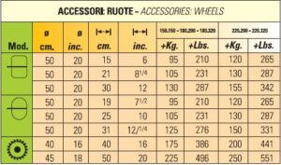

* **DOUBLE TOP HOOD**
* **LEVELER EXTENSION**
* **LATERAL SPILLWAYS**
* **2 FRONT SUBSOILERS**
* **ROUND SPADES FOR SOILS WITH STONES**
* **WIDE SPADES FOR PADDY/KIWI FIELDS**
* **LONG SPADES FOR SANDY SOILS**
* **HYDRAULIC LATERAL DISPLACEMENT:**  
  MAX 20 CM/8 INC LEFT/RIGHT.  
  This accessory makes it easier to maintain a constant distance with plants, but necessarily increases the weight, cost and length of the spade. We advise against its use where it is not essential.  
  +100 kg 220 Lbs
* 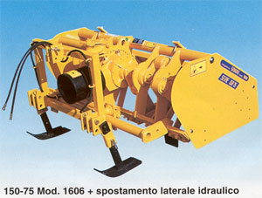

**FOR SANDY SOILS:**

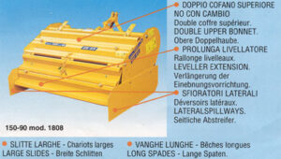

**FOR STONY SOILS:**

